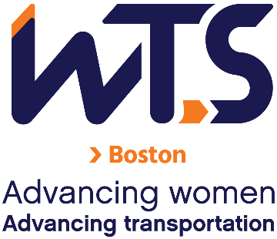
WTS-Boston Chapter
Formal Mentoring Program
Mentor Application

The WTS Boston Mentoring Committee is seeking participants for the 2027 Formal Mentoring Program. Please take a few minutes to review the program details below and consider becoming a mentor in the program. Applicants are very much appreciated for choosing to volunteer their time and wisdom to mentor emerging professionals.
Mentors will be paired with mentees based on their career/employment background, leadership experience, and the mentee’s stated professional and mentoring program goals. Previous mentoring experience is not necessary, but is a plus.
Applications are due Friday, November 13, 2026 to wtsbostonmentoring@gmail.com. If you have questions, reach out to the same email.

Expectations, Eligibility Criteria, and Requirements
Expectations:
- Ability to make a 6-month commitment from January-June 2027 encompassing about 2 hours/month to the program:
  - Mentor and mentee pairs should meet 1-on-1 once per month.
  - Additionally, group sessions will be during a Thursday lunch hour once per month. Sessions will either be in person or virtual. In-person sessions will be held in Downtown Boston, and virtual sessions will be held over Microsoft Teams.

Dates for group sessions:
- January 21 (Virtual, Introduction session)
- January 28 (In-person)
- Feb 18 (Virtual)
- March 18 (In-person)
- April 8 (Virtual)
- May 13 (In-person)
- June 10 (In-person)
*Dates may be subject to change.

Each group session will cover a professional development topic. Potential topics will include:
- Giving and receiving challenging feedback
- Transitioning to leadership and management
- Knowing and communicating your boundaries
- Effectively managing conflict

Eligibility:
- Interested mentors should be a current Member of WTS-Boston. To join WTS, visit the following link: https://www.wtsinternational.org/home/membership.
- Eligible mentors are those who:
  - Hold senior positions in transportation, public policy, or related fields and have the desire to assist others to grow personally and professionally; and/or
  - Are industry professionals with extensive experience in their chosen field with the ability to inspire their mentees to learn and grow, seek new possibilities, take calculated risks and act as allies, catalysts and coaches.

Requirements:
- Complete this application.
- Submit a resume and headshot (JPEG or PNG format please).
- Submit a 150-250 word bio describing your work history, leadership, and mentoring experience. Bio must adhere to the 250-word maximum.
*Incomplete submissions may not be considered. Please verify all required documents before submission.

Application
Name
Employer and/or Organization
Position/Title
Email
Phone Number

1. What are your expectations of the Mentoring Program? Why would you like to participate in the Program?

2. Please note your preferred way to communicate with a mentee (virtual/in-person) and your preferred days/times to meet for the 1-on-1s:

Please sign below to indicate that you understand and accept the expectations and the commitment of the program:

(Applicant’s signature)

Applications are due by Friday, November 13, 2026 to wtsbostonmentoring@gmail.com.

