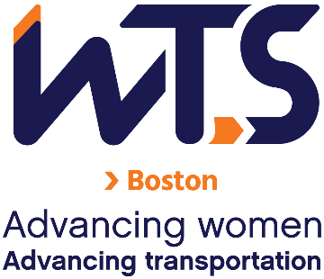
WTS-Boston Chapter
Formal Mentoring Program
Mentee Application

The WTS Boston Mentoring Committee is seeking participants for the 2027 Formal Mentoring Program.
This program will provide the opportunity for emerging professionals to access more experienced professionals in the industry, providing them with insights that could have a lasting and tangible effect on their careers. Mentors will offer their mentees guidance on how to approach challenges and how to identify and take advantage of opportunities. The program will also provide monthly professional development group sessions.
Participants will be selected based on their interest in the program and the thoroughness of their application. There are a limited number of available spots in this program.
Please take a few minutes to review the program details below and consider applying to the WTS Boston 2027 Formal Mentoring Program.
Applications are due Friday, November 13, 2026 to wtsbostonmentoring@gmail.com. If you have questions, reach out to the same email.
Expectations, Eligibility Criteria, and Requirements
Expectations:
- Ability to make a 6-month commitment from January-June 2027 encompassing about 2 hours/month to the program:
- Mentor and mentee pairs should meet 1-on-1 once per month.
- Additionally, group sessions will be during a Thursday lunch hour once per month. Sessions will either be in person or virtual. In-person sessions will be held in Downtown Boston, and virtual sessions will be held over Microsoft Teams.

Dates for group sessions:
- January 21 (Virtual, Introduction session)
- January 28 (In-person)
- Feb 18 (Virtual)
- March 18 (In-person)
- April 8 (Virtual)
- May 13 (In-person)
- June 10 (In-person)
*Dates may be subject to change.

Each group session will cover a professional development topic. Potential topics will include:
- Giving and receiving challenging feedback
- Transitioning to leadership and management
- Knowing and communicating your boundaries
- Effectively managing conflict
Eligibility:
- Current Member of WTS-Boston. To join WTS, visit the following link: https://www.wtsinternational.org/home/membership.

Requirements:
- Complete this application.
- Submit a resume and headshot (JPEG or PNG format please).
- Submit a 50-100 word bio describing your work history and experience. Bio must adhere to the 100-word maximum.
- Please provide us with a letter from your supervisor with their approval (for time commitment) to participate in this program.

* Incomplete submissions may not be considered. Please verify all required documents before submission.

Application
Name
Employer and/or Organization
Position/Title
Email
Phone Number
1. Briefly describe your professional goals:
2. Describe what you are looking for in a mentor:

Please sign below to indicate that you understand and accept the expectations and the commitment of the program:

(Applicant’s signature)

Applications are due by Friday, November 13, 2026 to wtsbostonmentoring@gmail.com.

