EVENT SPONSORSHIP OPPORTUNITY
15th Annual Transportation Reception &
Silent Auction for Scholarships
Wednesday, November 12, 2025 (6-8 pm)
Festival on 8th | 712 Atlantic Avenue, Virginia Beach, VA 23451
Join the Women’s Transportation Seminar (WTS) Hampton Roads Chapter as we celebrate our 15th Annual Transportation Reception and Silent Auction for Scholarships—an evening dedicated to recognizing excellence in transportation and raising funds to support the next generation of women leaders in the industry.
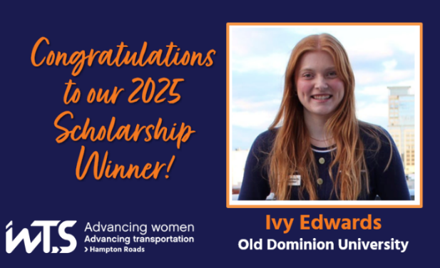
All proceeds from the silent auction will benefit the WTS Foundation Scholarship Fund, which provides financial support to local students pursuing careers in transportation.
Honoring Excellence in Transportation
We will proudly recognize the following award winners:
- 2025 Scholarship Recipient: Ivy Edwards - ODU
- Employer of the Year: Kimley-Horn
- Rosa Parks Diversity Award: RK&K's Women Employee Resource Group
- Woman of the Year: Paula Miller - HNTB
- Woman to Watch: Emily Hinkson, PE - HNTB
- Honorable Ray LaHood Award: Ray Amoruso - Hampton Roads Transit (HRT)
- Member of the Year: Sara Keranakis, PE - JMT
- Innovative Transportation Solutions Award: HRT OnDemand Ridesharing Microtransit
- Past President Recognition: Carly Goldsborough, PE - JMT
We expect to welcome around 100 guests, and 100% of silent auction proceeds will go directly to the WTS Foundation. Your support helps empower young women who are poised to transform the transportation industry.
These funds contribute to local scholarships for young women pursuing careers in transportation. Our local applicants have the potential to transform the transportation industry, and we need your help to make this year’s event the best yet!

How to Sponsor
- Submit the attached sponsorship form by October 20.

Thank you for supporting WTS Hampton Roads and our mission of Advancing Women in Transportation.
For questions, please contact us directly at wts.hrc@gmail.com.

EVENT SPONSORSHIP – WTS 15th Annual Transportation Reception
& Silent Auction for Scholarships

Signature Event Partner - $1,000 [Two sponsorships available]
- Three complimentary tickets
- Featured as “Signature Event Partner” on eblast promotions, display boards, and video montage
- Full page (8.5” x 5”) event program advertisement space
Keynote Event Partner - $750 [Four sponsorships available]
- Two complimentary tickets
- Featured as a “Keynote Event Partner” on display boards and video montage
- Half page (4.25” x 5”) event program advertisement space
Supporting Event Partner - $500 [Four sponsorships available]
- One complimentary ticket
- Featured as a “Supporting Event Partner” on display boards and video montage
- Quarter page (2.5” x 4.25”) event program advertisement space
Please submit this form and your company advertisement by: October 20
To request an electronic invoice, contact: WTS.HRC@gmail.com
For more information, contact:
- Sara Keranakis, PE - Programs Chair - 757-552-1040; or SKeranakis@jmt.com
- Jennifer Riddle - Chapter President - 757-631-5441 ; or wts.hrc@gmail.com
Company:
Point of Contact:
Phone & Email:
Partnership Level: | ☐ Signature Event Sponsor - $1,000  Complimentary Attendee 1: [Name and email address]  Complimentary Attendee 2: [Name and email address]  Complimentary Attendee 3: [Name and email address]
☐ Keynote Event Sponsor - $750
Complimentary Attendee 1: [Name and email address]
Complimentary Attendee 2: [Name and email address]
☐ Supporting Event Sponsor - $500
Complimentary Attendee 1: [Name and email address]

Please make checks payable to: WTS Hampton Roads Chapter
Please mail checks to:
Sara Keranakis, WTS HRC Programs Chair
c/o JMT
272 Bendix Road, Suite 260
Virginia Beach, VA 23452

