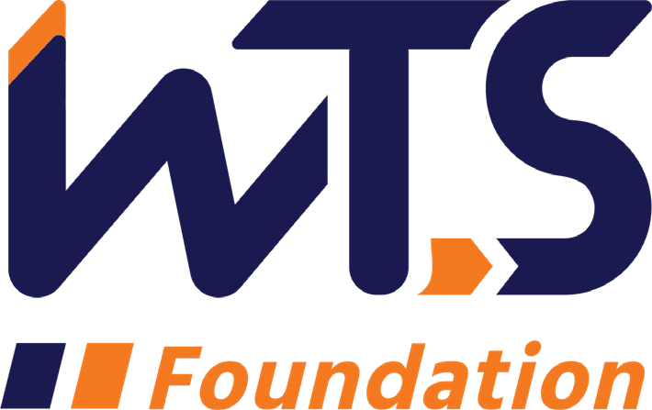

WTS Sharon D. Banks Memorial Undergraduate Scholarship

WTS fosters the development of women in the transportation field by encouraging bright new professionals to undertake careers in the area of transportation. One way it does this is by awarding the WTS Sharon D. Banks Memorial Scholarship to women pursuing undergraduate studies in transportation or a related field.

The scholarship honors Sharon D. Banks, chief executive officer of AC Transit in Alameda-Contra Costa County, California. As its CEO throughout most of the 1990’s, Banks led the agency in a pioneering effort to introduce cultural and organizational changes aimed at motivating the public transit workforce. She was a member of the WTS Advisory Board and received the WTS San Francisco Chapter Woman of the Year and Employer of the Year awards.

The WTS Sharon D. Banks Memorial Undergraduate Scholarship is $3,500. The minimum criteria for selection are:

- GPA of 3.0 or higher.
- Currently enrolled in an undergraduate degree program in a transportation- related field, such as transportation engineering, planning, finance, or logistics.
- Plans to pursue a career in a transportation-related field.

Applications must be submitted through local WTS chapters as typed documents. Scholarships are competitive and based on the applicant's specific transportation goals, academic record, and transportation-related activities or job skills. National awards will be presented during the upcoming WTS Annual Conference in May, and attendance during the awards ceremony is strongly recommended. Conference registration for scholarship winners is complimentary. Local chapters will assist with arrangements upon selection and may have additional requirements, such as personal interviews or higher GPA. Please contact your local WTS chapter for specifics.

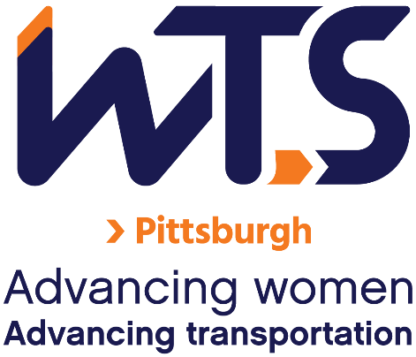

We can’t wait to review your application. Please use the checklist below to ensure your application is complete!

☐ Are you a woman currently enrolled in an undergraduate degree program in a transportation related field?

☐Do you plan to pursue a career in a transportation-related field?

☐ Do you have a GPA of 3.0 or higher?

☐Official copy of your transcript

☐One (1) letter of recommendation

☐Personal Statement

☐Proof of Enrollment

☐Completed application (following pages)

☐Do you attend school and/or permanently reside in Western Pennsylvania?

WTS Sharon D. Banks Memorial Undergraduate Scholarship Application

Date ________________

  - Personal Information

Name Last First Middle
E-mail Address Primary Phone Current Address (Street, City, State, Zip):

Permanent Address (Street, City, State, Zip):

Educational Background
Current College/University City, State Expected Date of Graduation
Degree to be Received
Area of Concentration Grade Point Average
(Minimum GPA of 3.0 required. Attach official copy of transcript to application.) Previous Colleges/Universities Attended, Date Degree Earned and GPA:

Professional or School Affiliations (List any school, professional or community activities you have participated in. Include offices held and awards received. Attach additional sheets, if necessary, as typed word documents.)

Employment History

Work Experience (List full-time, part-time, co-op and summer employment. Briefly describe duties and responsibilities. Attach additional sheets, if necessary, as typed word documents.)

  - Recommendation: Letter of recommendation by a professor or job supervisor must accompany your application.

  - Personal Statement: A statement about your career goals and/or continuing education after graduation and why you think that you should receive the scholarship award. Applicants must address the issue of leadership, its importance in a transportation career, and the applicant’s leadership achievements. Statement should not exceed 500 words. Please attach to application form as a typed word document.

  - Proof of Enrollment: Attach a copy of your tuition receipt or current registration card.

  - Demographic Information: WTS is committed to recognizing the achievements of students pursuing transportation related degrees. To track our progress in reaching diverse applicants, we ask that you complete this confidential demographic information. This is not required for scholarship awards and will not be used in the selection process.

Race/Ethnicity (select all that apply)

☐Asian

☐Black

☐East Indian

☐Hispanic/Latino

☐Indigenous

☐Middle Eastern

☐Multiracial

☐Pacific Islander

☐White

☐Other (please write in)

☐Choose not to disclose

Age

☐15-18

☐19-23

☐24-30

☐31-50

☐50+

Anticipated or Current Mode of Transportation Career Focus (select all that apply)

☐Aviation

☐Freight

☐Highway/Auto

☐Maritime/Port

☐Multi-modal

☐Non-Motorized

☐Passenger

☐Transit
☐Other (please write in)

How did you hear about this scholarship?

☐Friend

☐School/Teacher

☐Social Media:

☐Facebook

☐Instagram

☐LinkedIn

☐Snapchat

☐TikTok

☐Twitter

☐YouTube

☐Other (please write in)

☐WTS Chapter

☐WTS International Website
☐Other (please write in)

Applicant Signature Date

