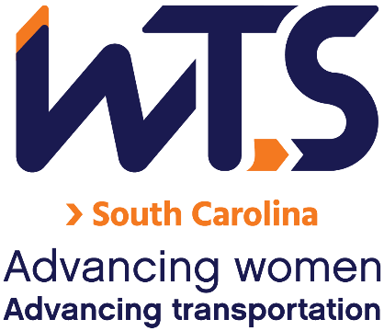

2024 WTS Transportation YOU

High School Scholarship

WTS fosters the development of women and girls in the transportation field by encouraging bright new professionals and students to undertake careers in the area of transportation. One way it does this is by awarding the WTS Transportation YOU High School Scholarship to girls pursuing high school studies in science, technology, engineering, and math.

The WTS-SC Chapter recognizes the importance of enriching Equity, Diversity, and Inclusion (ED&I) in the transportation industry. We value the contributions of each individual student, and celebrate everyone's capabilities regardless of ethnicity, race, age, and gender. In furthering our commitment to expanding the diversity of our student applicants and recognizing your achievements, we are adding an optional bonus ED&I essay question to the application that will allow you to increase your final evaluation score. We look forward to learning more about your experiences, thoughts, and contributions to enhancing diversity in the transportation industry.

The minimum criteria for selection are:

- Applicant must be a high school senior
- GPA of 3.0 or higher
- Currently studying math, science, and technology
- Considering a college degree in a transportation-related field

Applications should be submitted to the WTS South Carolina Chapter as typed documents and will compete locally for one $1,000 scholarship award. Scholarships are competitive and based on the applicant's specific transportation goals, academic record, and transportation-related activities or job skills. Applications are due March 1, 2024.

The local awards banquet is scheduled for late April 2024. Local winners will be forwarded and considered for the 2025 WTS Foundation (National) Awards. National awards will be presented during the Annual Conference and attendance during the awards ceremony is strongly recommended. Conference registration for scholarship winners is complimentary. Local chapters will assist with arrangements upon selection.

2024 WTS Transportation YOU High School Scholarship

Application

  - Personal Information

Name Last First Middle

E-mail address Primary Phone ( ) Current Address (Street, City, State, Zip):

Permanent Address (Street, City, State, Zip):

Educational Background

Current High School City, State Expected Date of Graduation Area of Concentration
Grade Point Average
(Minimum GPA of 3.0 required. Attach an official copy of the report card to the application.)

Professional or School Affiliations (List any school, professional, or community activities you have participated in. Include offices held and awards received. Attach additional sheets, if necessary, as typed word documents or in PDF format.)

  - Recommendation: A letter of recommendation by a teacher, counselor, or principal must accompany your application.

  - Personal Statement: A statement about your goals to pursue studies in STEM areas (science, technology, engineering, or math) while in college and why you think that you should receive the scholarship award. The statement should not exceed 500 words. Please attach as a word document or PDF to the application form.

  - Equity, Diversity, and Inclusion:
An optional bonus ED&I essay will allow you to increase your final evaluation score. We look forward to learning more about your experiences, thoughts, and contributions to enhancing diversity in the transportation industry. Please attach your optional bonus ED&I essay to your application.

You may choose one of the following questions for your essay (250 words):

- How do you think diversity helps the transportation industry?
- What role can you play in helping the transportation industry be more diverse?

Applicant Signature Date

Parent/Guardian
Signature Date

Please send the application and attachments with the subject line “Scholarship” to:
SouthCarolinaWTS@gmail.com

Optional Information: WTS is committed to recognizing the achievements of students pursuing transportation-related degrees. To track our progress in reaching diverse applicants, we ask that you complete this confidential demographic information. This is not required for scholarship awards and will not be used in the selection process.

Race/Ethnicity (select all that apply)

☐Caucasian

☐Other (please write in)________________________________________

☐Choose not to disclose

Age

☐15-18

☐19-23

☐24-30

Anticipated or Current Mode of Transportation Career Focus (select all that apply)

☐Aviation

☐Freight

☐Highway/Auto

☐Maritime/Port

☐Multi-modal

☐Non-Motorized

☐Passenger

☐Transit
☐Other (please write in)

How did you hear about this scholarship?

☐Friend

☐School/Teacher

☐Social Media:

☐Facebook

☐Instagram

☐LinkedIn

☐Snapchat

☐TikTok

☐Twitter

☐YouTube

☐WTS Chapter

☐WTS International Website
☐Other (please write in)

