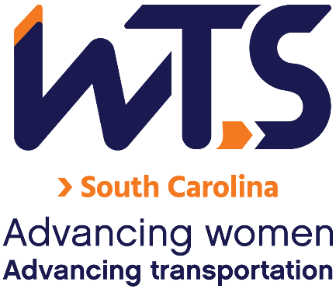

2024 WTS Helene M. Overly Memorial Scholarship
The WTS Helene M. Overly Memorial Scholarship was established in 1981 by WTS International to encourage women to pursue career paths in transportation. The scholarship is awarded to women pursuing graduate studies in transportation or a related field.

In memory of Helene M. Overly, the first Executive Secretary of WTS, the Board of Directors voted to name the annual WTS graduate scholarship the Helene M. Overly Memorial Scholarship to honor Helene for her dedicated service to WTS. Helene became a WTS member in 1981. She brought with her 15 years of experience in public service, tremendous organizational abilities, and a spirit of determination that helped WTS nearly double its membership in two years.

The WTS-SC Chapter recognizes the importance of enriching Equity, Diversity, and Inclusion (ED&I) in the transportation industry. We value the contributions of each individual student, and celebrate everyone's capabilities regardless of ethnicity, race, age, and gender. In furthering our commitment to expanding the diversity of our student applicants and recognizing your achievements, we are adding an optional bonus ED&I essay question to the application that will allow you to increase your final evaluation score. We look forward to learning more about your experiences, thoughts, and contributions to enhancing diversity in the transportation industry.

The minimum criteria for selection are:

- GPA of 3.0 or higher
- Currently enrolled in a graduate degree program in a transportation-related field, such as transportation engineering, planning, finance, or logistics
- Plans to pursue a career in a transportation-related field

Applications should be submitted to the WTS South Carolina Chapter as typed documents and will compete locally for one $3,000 scholarship award. Scholarships are competitive and based on the applicant's specific transportation goals, academic record, and transportation-related activities or job skills. Applications are due March 1, 2024.

The awards banquet is scheduled for late April 2024. Local winners will be forwarded and considered for the 2025 WTS Foundation (National) Awards. National awards will be presented during the Annual Conference and attendance during the awards ceremony is strongly recommended. Conference registration for scholarship winners is complimentary. Local chapters will assist with arrangements upon selection.

2024 WTS Helene M. Overly Memorial Scholarship Application

  - Personal Information

Name Last First Middle
E-mail Address
Primary Phone Current Address (Street, City, State, Zip):

Permanent Address (Street, City, State, Zip):

Educational Background
Current College/University
City, State Expected Date of Graduation
Degree to be Received
Area of Concentration Grade Point Average
(Minimum GPA of 3.0 required. Attach an official copy of the transcript to the application). Previous Colleges/Universities Attended, Date Degree Earned and GPA:

Professional or School Affiliations (List any school, professional or community activities you have participated in. Include offices held and awards received. Attach additional sheets, if necessary, as typed word documents).

Employment History

Work Experience (List full-time, part-time, co-op, and summer employment.
Briefly describe duties and responsibilities. Attach additional sheets, if necessary, as typed word documents.)

  - Recommendation: Two letters of recommendation by a professor or job supervisor must accompany your application.
  - Personal Statement: A statement about your career goals after graduation and why you think that you should receive the scholarship award. The statement should not exceed 500 words. Please attach to the application form as a typed word document.

  - Proof of Enrollment: Attach a copy of your tuition receipt or current registration card.

  - Equity, Diversity, and Inclusion:

An optional bonus ED&I essay will allow you to increase your final evaluation score. We look forward to learning more about your experiences, thoughts, and contributions to enhancing diversity in the transportation industry. Please attach your optional bonus ED&I essay to your application.

You may choose one of the following questions for your essay (250 words):

- How do you think diversity helps the transportation industry?
- What role can you play in helping the transportation industry be more diverse?

Applicant Signature Date

Please send the application and attachments with the subject line “Scholarship” to:
SouthCarolinaWTS@gmail.com

Optional Information: WTS is committed to recognizing the achievements of students pursuing transportation-related degrees. To track our progress in reaching diverse applicants, we ask that you complete this confidential demographic information. This is not required for scholarship awards and will not be used in the selection process.

Race/Ethnicity (select all that apply)

☐Caucasian

☐Other (please write in)________________________________________

☐Choose not to disclose

Age

☐15-18

☐19-23

☐24-30

☐31-50

☐50+

Anticipated or Current Mode of Transportation Career Focus (select all that apply)

☐Aviation

☐Freight

☐Highway/Auto

☐Maritime/Port

☐Multi-modal

☐Non-Motorized

☐Passenger

☐Transit
☐Other (please write in)

How did you hear about this scholarship?

☐Friend

☐School/Teacher

☐Social Media:

☐Facebook

☐Instagram

☐LinkedIn

☐Snapchat

☐TikTok

☐Twitter

☐YouTube

☐WTS Chapter

☐WTS International Website
☐Other (please write in)

