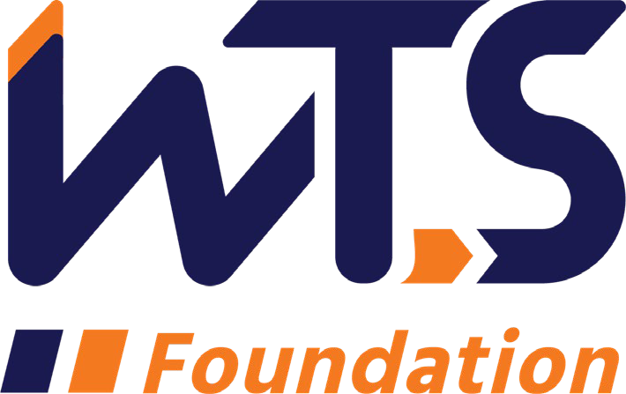

2023-24 WTS Transportation YOU

High School Scholarship

WTS fosters the development of women and girls in the transportation field by encouraging bright new professionals and students to undertake careers in the area of transportation. One way it does this is by awarding the WTS Transportation YOU High School Scholarship to girls pursuing high school studies in science, technology, engineering, and math.

Transportation YOU is a hands-on, interactive, mentoring program that offers young girls ages 13-18 an introduction to a wide variety of transportation careers. Through the Transportation YOU program and this scholarship, WTS chapters work to make a difference in the lives of young girls by offering opportunities and activities that will spark their interest in all modes of transportation and encourage them to take courses in math, science, and technology, which are the stepping stones to exciting careers that can change the face of the transportation industry.

The WTS Transportation YOU High School Scholarship is $2,500. The minimum criteria for selection are:

- Applicant must be female or female identifying
- Must live, or go to school either the nine-county San Francisco Bay Area, three-county Monterey Bay Area or San Luis Obispo County.
- Applicant must be a high school senior
- GPA of 3.0 or higher
- Currently studying math, science, and technology
- Considering a college degree in a transportation-related field such as city/transportation planning, engineering, government policy, logistics, aviation, etc.

Scholarships are competitive and based on the applicant's leadership experience, specific transportation goals, academic record, and transportation-related activities or job skills. Applications must be submitted to Marcella Rensi at marcella.rensi@vta.orgas typed documents by January 3, 2024.

The San Francisco Bay Area Chapter awards will be presented during the chapter’s annual event in June 2024. International awards will be presented at the WTS Annual Conference in New Orleans in May 2024. Attendance during the awards ceremony is strongly recommended. Conference registration is free for scholarship winners and the chapter will cover travel and hotel costs.

2023-24 WTS Transportation YOU High School Scholarship

Application

  - Personal Information

Name Last First Middle

E-mail address Primary Phone ( ) Current Address (Street, City, State, Zip):

Permanent Address (Street, City, State, Zip):

Educational Background

Current High School City, State Expected Date of Graduation Area of Concentration
Grade Point Average
(Minimum GPA of 3.0 required. Attach official copy of report card to application.)

Professional or School Affiliations (List any school, professional or community activities you have participated in. Include offices held and awards received. Attach additional sheets, if necessary, as typed word documents or in PDF format.)

  - Recommendation: At least one letter of recommendation by a teacher, counselor, or principal must accompany your application. It can be sent directly to marcella.rensi@vta.org
  - Personal Statement: A statement about your goals to pursue studies in STEM areas (science, technology, engineering, or math) while in college and why you think that you should receive the scholarship award. Statement should not exceed 500 words. Please attach as a word document or PDF to application form.

  - Demographic Information: WTS is committed to recognizing the achievements of students pursuing transportation related degrees. To track our progress in reaching diverse applicants, we ask that you complete this confidential demographic information. This is not required for scholarship awards and will not be used in the selection process.

Race/Ethnicity (select all that apply)

☐Asian

☐Black

☐East Indian

☐Hispanic/Latino

☐Indigenous

☐Middle Eastern

☐Multiracial

☐Pacific Islander

☐White

☐Other (please write in)

☐Choose not to disclose

Age

☐15-18

☐19-23

☐24-30

☐31-50

☐50+

Anticipated or Current Mode of Transportation Career Focus (select all that apply)

☐Aviation

☐Freight

☐Highway/Auto

☐Maritime/Port

☐Multi-modal

☐Non-Motorized

☐Passenger

☐Transit
☐Other (please write in)

How did you hear about this scholarship?

☐Friend

☐School/Teacher

☐Social Media:

☐Facebook

☐Instagram

☐LinkedIn

☐Snapchat

☐TikTok

☐Twitter

☐YouTube

☐Other (please write in)

☐WTS Chapter

☐WTS International Website
☐Other (please write in)

Applicant Signature Date

Parent/Guardian
Signature Date

Alameda, Contra Costa, Marin, Napa, San Francisco, San Mateo, Santa Clara, Solano, Sonoma
Monterey, San Benito, Santa Cruz

