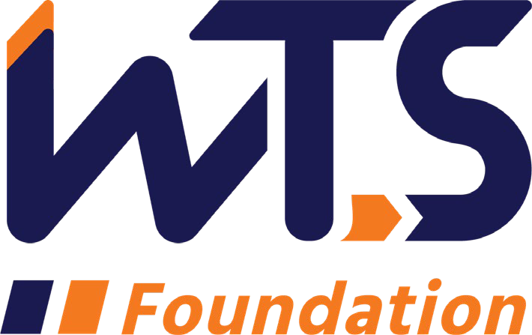

2023-24 WTS Sharon D. Banks Memorial

Undergraduate Scholarship

WTS fosters the development of women in the transportation field by encouraging bright new professionals to undertake careers in transportation. One way it does this is by awarding the WTS Sharon D. Banks Memorial Scholarship to women pursuing undergraduate studies in transportation or a related field.

The scholarship honors Sharon D. Banks, chief executive officer of AC Transit in Alameda and Contra Costa counties, in California’s San Francisco Bay Area. As its General Manager throughout most of the 1990’s, Banks led the agency in a pioneering effort to introduce cultural and organizational changes aimed at motivating the public transit workforce. She was a member of the WTS Advisory Board and received the WTS San Francisco Chapter Woman of the Year and Employer of the Year awards. She was also the first Black woman to chair the American Public Transit Association (APTA).

The WTS San Francisco Bay Chapter’s Sharon D. Banks Memorial Undergraduate Scholarship is $5,000. Our chapter’s winner will be entered in the WTS International scholarship competition, for an additional $5,000. The minimum criteria for selection are:

- Female or female identifying
- Must come from, live, or go to school either the nine-county San Francisco Bay Area, three-county Monterey Bay Area or San Luis Obispo County.
- GPA of 3.0 or higher.
- Currently enrolled in an undergraduate degree program in a transportation- related field, such as transportation engineering, planning, finance, or logistics.
- Plans to pursue a career in a transportation-related field.

Scholarships are competitive and based on the applicant's specific transportation goals, academic record, and transportation-related activities or job skills. Applications must be submitted to Marcella Rensi at marcella.rensi@vta.orgas typed documents by January 3, 2024.

The San Francisco Bay Area awards will be presented at the chapter’s annual event in June 2024. International awards will be presented at the WTS Annual Conference in New Orleans in May 2024. Attendance is strongly recommended. The conference is free for scholarship winners and the chapter will cover travel and hotel costs.

2023-24 WTS Sharon D. Banks Memorial Undergraduate Scholarship

Application

  - Personal Information

Name Last First Middle
E-mail Address Primary Phone Current Address (Street, City, State, Zip):

Permanent Address (Street, City, State, Zip):

Educational Background
Current College/University City, State Expected Date of Graduation
Degree to be Received
Area of Concentration Grade Point Average
(Minimum GPA of 3.0 required. Official transcript required, may send separately) Previous Colleges/Universities Attended, Date Degree Earned and GPA:

Professional or School Affiliations (List any school, professional or community activities you have participated in. Include offices held and awards received. Attach additional sheets, if necessary, as typed word documents.)

Employment History

Work Experience (List full-time, part-time, co-op and summer employment. Briefly describe duties and responsibilities. Attach additional sheets, if necessary, as typed word documents.)

  - Recommendation: At least one letter of recommendation by a professor or job supervisor is required. This can be sent separately to marcella.rensi@vta.org.

  - Personal Statement: A statement about your career goals and/or continuing education after graduation and why you think that you should receive the scholarship award. Applicants must address the issue of leadership, its importance in a transportation career, and the applicant’s leadership achievements. Statement should not exceed 500 words. Please attach to application form as a typed word document.

  - Proof of Enrollment: Attach a copy of your tuition receipt or current registration card.

  - Demographic Information: WTS is committed to recognizing the achievements of students pursuing transportation related degrees. To track our progress in reaching diverse applicants, we ask that you complete this confidential demographic information. This is not required for scholarship awards and will not be used in the selection process.

Race/Ethnicity (select all that apply)

☐Asian

☐Black

☐East Indian

☐Hispanic/Latino

☐Indigenous

☐Middle Eastern

☐Multiracial

☐Pacific Islander

☐White

☐Other (please write in)

☐Choose not to disclose

Age

☐15-18

☐19-23

☐24-30

☐31-50

☐50+

Anticipated or Current Mode of Transportation Career Focus (select all that apply)

☐Aviation

☐Freight

☐Highway/Auto

☐Maritime/Port

☐Multi-modal

☐Non-Motorized

☐Passenger

☐Transit
☐Other (please write in)

How did you hear about this scholarship?

☐Friend

☐School/Teacher

☐Social Media:

☐Facebook

☐Instagram

☐LinkedIn

☐Snapchat

☐TikTok

☐Twitter

☐YouTube

☐Other (please write in)

☐WTS Chapter

☐WTS International Website
☐Other (please write in)

Applicant Signature Date

Alameda, Contra Costa, Marin, Napa, San Francisco, San Mateo, Santa Clara, Solano, Sonoma
Monterey, San Benito, Santa Cruz

