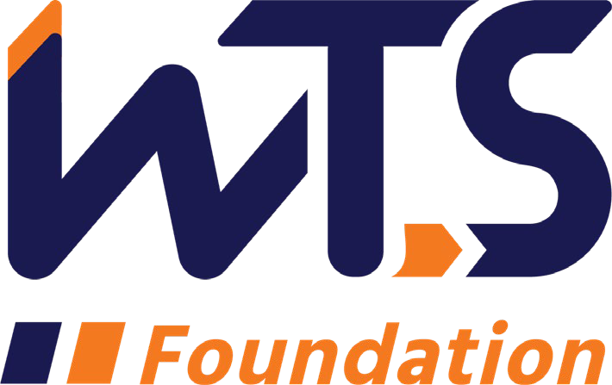

2023-24 WTS Helene M. Overly Memorial Scholarship

The WTS Helene M. Overly Memorial Scholarship was established in 1981 by WTS International to encourage women to pursue career paths in transportation. The scholarship is awarded to women pursuing graduate studies in transportation or a related field.

In memory of Helene M. Overly, the first Executive Secretary of WTS, the Board of Directors voted to name the annual WTS graduate scholarship the Helene M. Overly Memorial Scholarship to honor Helene for her dedicated service to WTS. Helene became a WTS member in 1981. She brought with her 15 years of experience in public service, tremendous organizational abilities, and a spirit of determination that helped WTS nearly double its membership in two years.

The WTS San Francisco Bay Chapter’s Helene M. Overly Memorial Scholarship is $5,000. The recipient will be submitted to WTS International to compete for an additional $10,000. The minimum criteria for selection are:

- Must be female and/or identify as female.
- GPA of 3.0 or higher.
- Currently enrolled in a graduate degree program in a transportation-related field, such as transportation engineering, planning, finance, or logistics.
- Plans to pursue a career in a transportation-related field.
- Must come from, live, or go to school either the nine-county San Francisco Bay Area, three-county Monterey Bay Area or San Luis Obispo County.

Scholarships are competitive and based on the applicant's specific transportation goals, academic record, and transportation-related activities or job skills. Applications must be submitted to Marcella Rensi at marcella.rensi@vta.orgas typed documents by January 3, 2024.

The San Francisco Chapter awards will be presented during the Chapter’s annual event in June 2024. International awards will be presented at the WTS Annual Conference in New Orleans in May 2024. Attendance during the awards ceremony is strongly recommended. Conference registration for scholarship winners is complimentary and the chapter will cover travel and hotel costs.

2023-24WTS Helene M. Overly Memorial Scholarship Application

  - Personal Information

Name Last First Middle
E-mail Address
Primary Phone Current Address (Street, City, State, Zip):

Permanent Address (Street, City, State, Zip):

Educational Background
Current College/University

City, State Expected Date of Graduation
Degree to be Received
Area of Concentration Grade Point Average
(Minimum GPA of 3.0 required. Official transcript required, may send separately)
Previous Colleges/Universities Attended, Date Degree Earned and GPA:

Professional or School Affiliations (List any school, professional or community activities you have participated in. Include offices held and awards received. Attach additional sheets, if necessary, as typed word documents.)

Employment History

Work Experience (List full-time, part-time, co-op and summer employment.
Briefly describe duties and responsibilities. Attach additional sheets, if necessary, as typed word documents.)

  - Recommendation: Two letters of recommendation by a professor or job supervisor are required. Letters may be sent directly to marcella.rensi@vta.org

  - Personal Statement: A statement about your career goals after graduation and why you think that you should receive the scholarship award. Statement should not exceed 500 words. Please attach to application form as a typed word document.

  - Proof of Enrollment: Attach a copy of your tuition receipt or current registration card.

  - Demographic Information: WTS is committed to recognizing the achievements of students pursuing transportation related degrees. To track our progress in reaching diverse applicants, we ask that you complete this confidential demographic information. This is not required for scholarship awards and will not be used in the selection process.

Race/Ethnicity (select all that apply)

☐Asian

☐Black

☐East Indian

☐Hispanic/Latino

☐Indigenous

☐Middle Eastern

☐Multiracial

☐Pacific Islander

☐White

☐Other (please write in)

☐Choose not to disclose

Age

☐15-18

☐19-23

☐24-30

☐31-50

☐50+

Anticipated or Current Mode of Transportation Career Focus (select all that apply)

☐Aviation

☐Freight

☐Highway/Auto

☐Maritime/Port

☐Multi-modal

☐Non-Motorized

☐Passenger

☐Transit
☐Other (please write in)

How did you hear about this scholarship

☐Friend

☐School/Teacher

☐Social Media:

☐Facebook

☐Instagram

☐LinkedIn

☐Snapchat

☐TikTok

☐Twitter

☐YouTube

☐Other (please write in)

☐WTS Chapter

☐WTS International Website
☐Other (please write in)

Applicant Signature Date

Alameda, Contra Costa, Marin, Napa, San Francisco, San Mateo, Santa Clara, Solano, Sonoma
Monterey, San Benito, Santa Cruz

