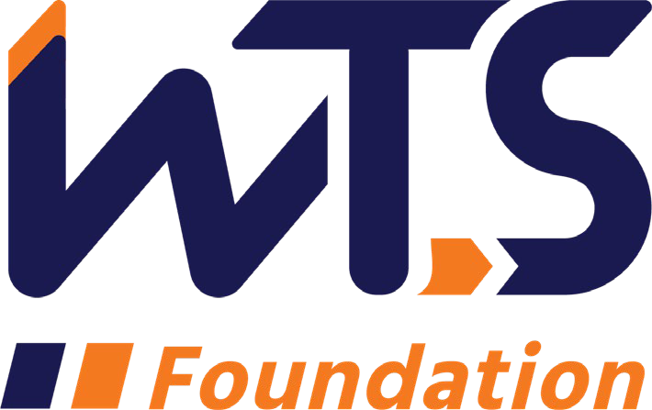

# 2023-24 WTS Transportation YOU

# High School Scholarship

WTS fosters the development of women and girls in the transportation field by encouraging bright new professionals and students to undertake careers in the area of transportation. One way it does this is by awarding the WTS Transportation YOU High School Scholarship to girls pursuing high school studies in science, technology, engineering, and math.

*Transportation YOU* is a hands-on, interactive, mentoring program that offers young girls ages 13-18 an introduction to a wide variety of transportation careers. Through the Transportation YOU program and this scholarship, WTS chapters work to make a difference in the lives of young girls by offering opportunities and activities that will spark their interest in all modes of transportation and encourage them to take courses in math, science, and technology, which are the stepping stones to exciting careers that can change the face of the transportation industry.

The **WTS Northeast Florida Chapter** is accepting applications for the Transportation YOU High School Scholarship through **December 5, 2023.** High school seniors in Northeast Florida* who are anticipating seeking a degree in a transportation-related field are encouraged to apply.

The recipient of the **WTS Northeast Florida Chapter** Transportation YOU scholarship will receive up to a **$1,000** scholarship and a complimentary WTS Northeast Florida Chapter student membership. The scholarship recipients are encouraged to make the most of the Chapter membership by participating in our monthly inspiring programs and behind-the-scenes tours designed to educate our members on various transportation-related topics.

One local recipient’s winning application will also be sent to the WTS Foundation for consideration of the National scholarship in the amount of **$2,500.** The minimum criteria for selection are:

1. Applicant must be a high school senior
2. GPA of 3.0 or higher
3. Currently studying math, science, and technology
4. Considering a college degree in a transportation-related field

Applications must be submitted to the **WTS Northeast Florida Chapter** as typed documents. Scholarships are competitive and based on the applicant's specific transportation goals, academic record, and transportation-related activities or job skills. National awards will be presented during the WTS Annual Conference in May 2024, and attendance during the awards ceremony is strongly recommended. Conference registration for scholarship winners is complimentary. Local chapters will assist with arrangements upon selection and may have additional requirements, such as personal interviews or higher GPA. Please contact the local WTS chapter at the address listed on the application for specifics.

The WTS Northeast Florida Chapter will also recognize each winner, details will be provided when available.

To apply, applicants must complete the following steps:

1. Email completed application and supporting documents to [northeastfloridawts@gmail.com](mailto:northeastfloridawts@gmail.com) and [cheryl@go321strategies.com](mailto:cheryl@go321strategies.com)
2. Please have official transcript mailed to the following address:

Cheryl Freeman

Scholarship Chair

WTS Northeast Florida Chapter

PO Box 41201

Jacksonville, FL 32203-1201

Please direct any questions to Cheryl Freeman, WTS Northeast Florida Chapter Scholarship Chair, at 904-608-8751 or [cheryl@go321strategies.com](https://d.docs.live.net/2e31fde5a4a3c6c4/Documents/WTS/Scholarship/2021%20Applications/2021%20Scolarship%20Application%20Forms/cheryl@go321strategies.com).Additional information about WTS and the scholarship program can be found on the WTS International website [wtsinternational.org.](https://d.docs.live.net/2e31fde5a4a3c6c4/Documents/WTS/Scholarship/2021%20Applications/Chapter%20Forms%20%5e0%20Documents/WTS%20Foundation%20Scholarship%20Materials/2020%20Materials/wtsinternational.org)

*\*Students must either have a permanent residence or attend school within Northeast Florida, which is considered Baker County, Clay County, Columbia County, Duval County, Flagler County, Nassau County, and St. Johns County.*

# 2023-24 WTS Transportation YOU High School Scholarship

# Application

* 1. **Personal Information**

Name Last First Middle

E-mail address Primary Phone ( ) Current Address (Street, City, State, Zip):

Permanent Address (Street, City, State, Zip):

# Educational Background

Current High School City, State Expected Date of Graduation Area of Concentration

Grade Point Average

(Minimum GPA of 3.0 required. Attach official copy of report card to application.)

Professional or School Affiliations (List any school, professional or community activities you have participated in. Include offices held and awards received. Attach additional sheets, if necessary, as typed word documents or in PDF format.)

* 1. **Recommendation**: Letter of recommendation by a teacher, counselor, or principal must accompany your application.
  2. **Personal Statement**: A statement about your goals to pursue studies in STEM areas (science, technology, engineering, or math) while in college and why you think that you should receive the scholarship award. Statement should not exceed 500 words. Please attach as a word document or PDF to application form.
  3. **Demographic Information:** WTS is committed to recognizing the achievements of students pursuing transportation related degrees. To track our progress in reaching diverse applicants, we ask that you complete this confidential demographic information. **This is not required for scholarship awards and will not be used in the selection process.**

# Race/Ethnicity (select all that apply)

# Asian

# Black

# East Indian

# Hispanic/Latino

# Indigenous

# Middle Eastern

# Multiracial

# Pacific Islander

# White

# Other (please write in)

# Choose not to disclose

# Age

# 15-18

# 19-23

# 24-30

# 31-50

# 50+

# Anticipated or Current Mode of Transportation Career Focus (select all that apply)

# Aviation

# Freight

# Highway/Auto

# Maritime/Port

# Multi-modal

# Non-Motorized

# Passenger

# Transit

Other (please write in)

# 

# How did you hear about this scholarship?

# Friend

# School/Teacher

# Social Media:

# Facebook

# Instagram

# LinkedIn

# Snapchat

# TikTok

# Twitter

# YouTube

# Other (please write in)

# WTS Chapter

# WTS International Website

Other (please write in)

Applicant Signature Date

Parent/Guardian

Signature Date ­­­­