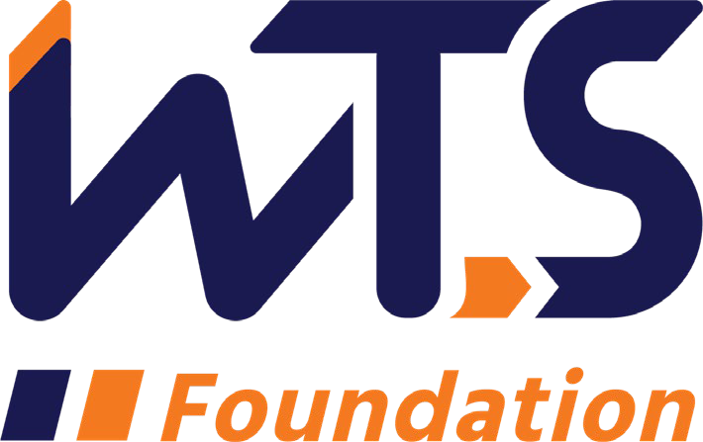

2023-24 WTS Sharon D. Banks Memorial

Undergraduate Scholarship

WTS fosters the development of women in the transportation field by encouraging bright new professionals to undertake careers in the area of transportation. One way the WTS Pittsburgh Chapter does this is by providing a $2,500 scholarship to a woman pursuing undergraduate studies in transportation or a related field.

The scholarship honors Sharon D. Banks, chief executive officer of AC Transit in Alameda-Contra Costa County, California. As its CEO throughout most of the 1990’s, Banks led the agency in a pioneering effort to introduce cultural and organizational changes aimed at motivating the public transit workforce. She was a member of the WTS Advisory Board and received the WTS San Francisco Chapter Woman of the Year and Employer of the Year awards.

The minimum criteria for selection are:

- GPA of 3.0 or higher.
- Currently enrolled in an undergraduate degree program in a transportation- related field, such as transportation engineering, planning, finance, or logistics.
- Plans to pursue a career in a transportation-related field.

Applications must be submitted through local WTS chapters as typed documents. Scholarships are competitive and based on the applicant's specific transportation goals, academic record, and transportation-related activities or job skills. The local award winner will be announced in early 2024 and honored at the WTS Pittsburgh Scholarship Gala in Spring 2023. National awards will be presented during the WTS Annual Conference in May 2024, in New Orleans, LA. Attendance at both awards ceremonies is strongly recommended for winning applicants. Conference registration for international winners' scholarship winners is complimentary. Travel expenses to attend the conference in New Orleans will be paid by the Pittsburgh Chapter.

There are two ways to submit your application:

- On paper – fill out this application form, print and mail it to the address below with the required attachments (personal statement, proof of enrollment, transcript, and recommendations). PLEASE DO NOT STAPLE.
Ms. Jennifer K. McCracken
WTS Scholarship Committee
314 Regent Court
McDonald, PA 15057

- Via e-mail – you may submit this application form and/or required attachments directly to the WTS-Pittsburgh Scholarship Committee using the e-mail address:
jennifer.mccracken@aecom.com

Applications must be received no later than Wednesday, November 22, 2023.

Any questions about the application process can be e-mailed to Jennifer McCracken at: jennifer.mccracken@aecom.com.

2023-24 WTS Sharon D. Banks Memorial Undergraduate Scholarship

Application

  - Personal Information

Name Last First Middle
E-mail Address Primary Phone Current Address (Street, City, State, Zip):

Permanent Address (Street, City, State, Zip):

Educational Background
Current College/University City, State Expected Date of Graduation
Degree to be Received
Area of Concentration Grade Point Average
(Minimum GPA of 3.0 required. Attach official copy of transcript to application.) Previous Colleges/Universities Attended, Date Degree Earned and GPA:

Professional or School Affiliations (List any school, professional or community activities you have participated in. Include offices held and awards received. Attach additional sheets, if necessary, as typed word documents.)

Employment History

Work Experience (List full-time, part-time, co-op and summer employment. Briefly describe duties and responsibilities. Attach additional sheets, if necessary, as typed word documents.)

  - Recommendation: Letter of recommendation by a professor or job supervisor must accompany your application.

  - Personal Statement: A statement about your career goals and/or continuing education after graduation and why you think that you should receive the scholarship award. Applicants must address the issue of leadership, its importance in a transportation career, and the applicant’s leadership achievements. Statement should not exceed 500 words. Please attach to application form as a typed word document.

  - Proof of Enrollment: Attach a copy of your tuition receipt or current registration card.

  - Demographic Information: WTS is committed to recognizing the achievements of students pursuing transportation related degrees. To track our progress in reaching diverse applicants, we ask that you complete this confidential demographic information. This is not required for scholarship awards and will not be used in the selection process.

Race/Ethnicity (select all that apply)

☐Asian

☐Black

☐East Indian

☐Hispanic/Latino

☐Indigenous

☐Middle Eastern

☐Multiracial

☐Pacific Islander

☐White

☐Other (please write in)

☐Choose not to disclose

Age

☐15-18

☐19-23

☐24-30

☐31-50

☐50+

Anticipated or Current Mode of Transportation Career Focus (select all that apply)

☐Aviation

☐Freight

☐Highway/Auto

☐Maritime/Port

☐Multi-modal

☐Non-Motorized

☐Passenger

☐Transit
☐Other (please write in)

How did you hear about this scholarship?

☐Friend

☐School/Teacher

☐Social Media:

☐Facebook

☐Instagram

☐LinkedIn

☐Snapchat

☐TikTok

☐Twitter

☐YouTube

☐Other (please write in)

☐WTS Chapter

☐WTS International Website
☐Other (please write in)

Applicant Signature Date

