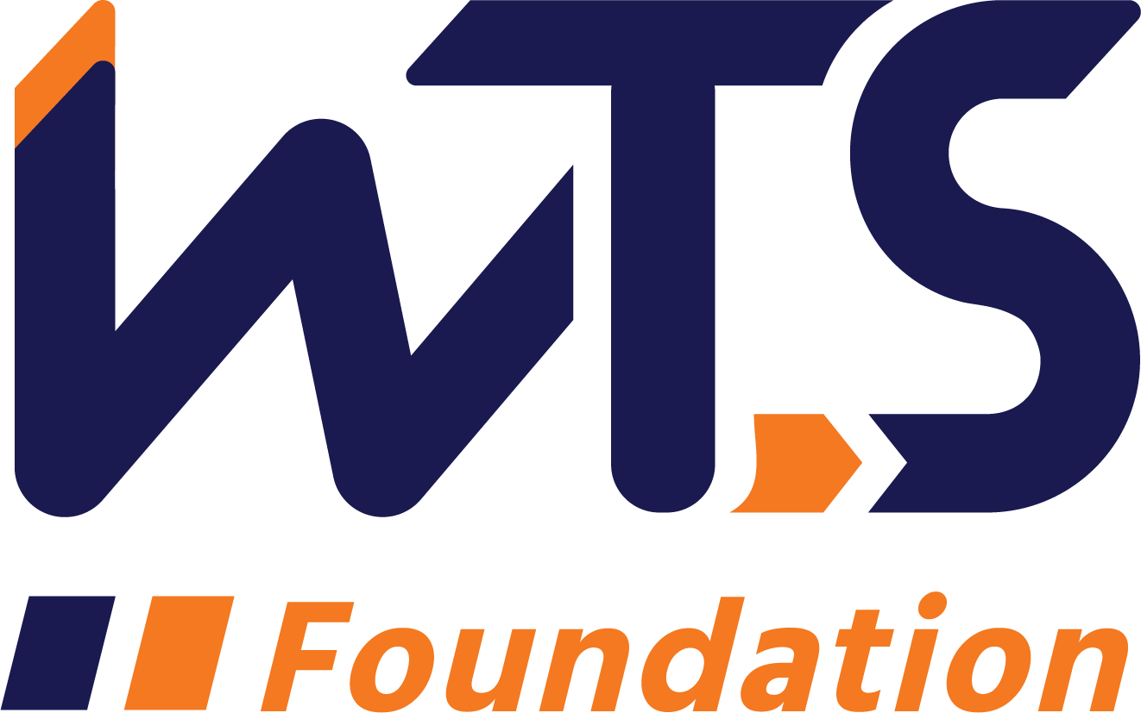

Memorial Graduate or Undergraduate Scholarship
WTS Southwest Idaho Chapter

WTS fosters the development of women in the transportation field by encouraging bright new professionals to undertake careers in the area of transportation. One way it does this is by awarding the WTS Memorial Scholarship to women pursuing graduate or undergraduate studies in transportation or a related field.

The Undergraduate Scholarship honors Sharon D. Banks, Chief Executive Officer of AC Transit in Alameda-Contra Costa County, California. As its CEO throughout most of the 1990’s, Banks led the agency in a pioneering effort to introduce cultural and organizational changes aimed at motivating the public transit workforce. She was a member of the WTS Advisory Board and received the WTS San Francisco Chapter Woman of the Year and Employer of the Year awards.

The Graduate Scholarship honors Helene M. Overly, the first Executive Secretary of WTS, the Board of Directors voted to name the annual WTS graduate scholarship the Helene M. Overly Memorial Scholarship to honor Helene for her dedicated service to WTS. Helene became a WTS member in 1981. She brought with her 15 years of experience in public service, tremendous organizational abilities, and a spirit of determination that helped WTS nearly double its membership in two years.

The WTS SW Idaho Chapter will award one $2,500 for the Sharon D. Banks Memorial Undergraduate Scholarship or the Helene M. Overly Memorial Graduate Scholarship. The winner of the WTS SW Idaho Chapter scholarship will advance to the national scholarship competition to represent the WTS SW Idaho Chapter with the opportunity to receive an additional $5,000 for undergraduate students or $10,000 for graduate students. The minimum criteria for selection are:

a. GPA of 3.0 or higher.
b. Currently enrolled in an undergraduate or graduate degree program in a transportation-related field, such as transportation engineering, planning, finance, or logistics.
c. Plans to pursue a career in a transportation-related field.

Applications must be submitted to the WTS SW Idaho Chapter as typed Word documents. The scholarships are competitive and based on the applicant's specific transportation goals, academic record and transportation-related activities or job skills. WTS SW Idaho Chapter scholarships will be awarded in December and scholarship recipients will be honored at a reception on April 17, 2024. Recipient’s attendance at this reception is strongly encouraged as an opportunity to meet transportation leaders and professionals in Southwest Idaho. If you have additional questions, email: wtsidahoscholarship@gmail.com.

Please return the completed application via email to: wtsidahoscholarship@gmail.com.

Please include all required forms, letters, transcripts, etc. in one package.
Applications must be postmarked no later than November 30, 2023.
WTS SW Idaho Chapter
Memorial Scholarship Application

I. Personal Information

Name:
Last First Middle

E-mail Address:
Primary Phone:

Current Address (Street, City, State, Zip):

Permanent Address (Street, City, State, Zip):

Educational Background
Current College/University:

City, State:

Expected Date of Graduation:

Degree to be Received:

Area of Concentration:

Grade Point Average:
(Minimum GPA of 3.0 required. Attach official copy of transcript to application.)

Previous Colleges/Universities Attended, Date Degree Earned and GPA:

Professional or School Affiliations (List any school, professional or community activities you have participated in. Include offices held and awards received. Attach additional sheets, if necessary, as typed word documents.)

III. Employment History

Work Experience (List full-time, part-time, co-op and summer employment. Briefly describe duties and responsibilities. Attach additional sheets, if necessary, as typed word documents.)

IV. Recommendation: Letter of recommendation by a professor or job supervisor must accompany your application.

V. Personal Statement: A statement about your career goals and/or continuing education after graduation and why you think that you should receive the scholarship award. Applicants must address the issue of leadership, its importance in a transportation career, and the applicant’s leadership achievements. Statement should not exceed 500 words. Please attach to application form as a typed word document.

VI. Proof of Enrollment: Attach a copy of your tuition receipt or current registration card.

VII. Demographic Information: WTS is committed to recognizing the achievements of students pursuing transportation related degrees. To track our progress in reaching diverse applicants, we ask that you complete this confidential demographic information. This is not required for scholarship awards and will not be used in the selection process.

- Race/Ethnicity (select all that apply)
Asian
Black
East Indian
Hispanic/Latino
Indigenous
Middle Eastern
Multiracial
Pacific Islander
White
Other (Please write in)___________________________________________
Choose Not to Disclose

- Age
15-18
19-23
24-30
31-50
50 +

- Anticipated or Current Mode of Transportation Career Focus (select all that apply)
Aviation
Freight
Highway/Auto
Maritime/Port
Multi-Modal
Non-Motorized
Passenger
Transit
Other (Please write in)

- How did you hear about this scholarship?
Friend
School/Teacher
Social Media:
Facebook
Instagram
LinkedIn
Snapchat
TikTok
Twitter
YouTube
Other (Please write in)____________________________________
WTS Chapter
WTS International Website
Other (Please write in)___________________________________________

Applicant Signature:

Date:

