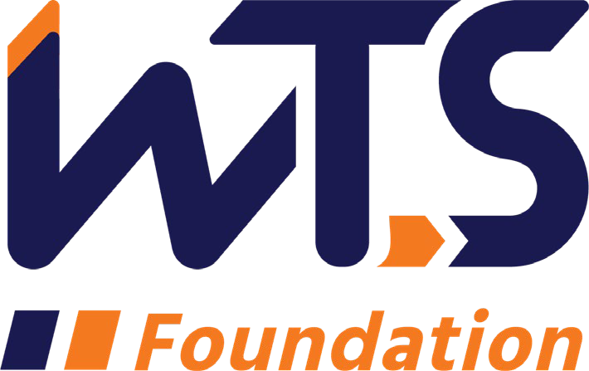

WTS Helene M. Overly Memorial Scholarship

The WTS Helene M. Overly Memorial Scholarship was established in 1981 by WTS International to encourage women to pursue career paths in transportation. The scholarship is awarded to women pursuing graduate studies in transportation or a related field.

In memory of Helene M. Overly, the first Executive Secretary of WTS, the Board of Directors voted to name the annual WTS graduate scholarship the Helene M. Overly Memorial Scholarship to honor Helene for her dedicated service to WTS. Helene became a WTS member in 1981. She brought with her 15 years of experience in public service, tremendous organizational abilities, and a spirit of determination that helped WTS nearly double its membership in two years.

The WTS Helene M. Overly Memorial Scholarship is $5,000 at the chapter level and $10,000 at the national level. The chapter level recipient will be submitted for consideration at the national level. The minimum criteria for selection are:

- GPA of 3.0 or higher.
- Currently enrolled in a graduate degree program in a transportation-related field, such as transportation engineering, planning, finance, or logistics.
- Plans to pursue a career in a transportation-related field.

Applications must be submitted through local WTS chapters as typed documents. Scholarships are competitive and based on the applicant's specific transportation goals, academic record, and transportation-related activities or job skills. National awards will be presented during the WTS Annual Conference in May 2022, and attendance during the awards ceremony is strongly recommended. Conference registration for scholarship winners is complimentary. Local chapters will assist with arrangements upon selection and may have additional requirements, such as personal interviews or higher GPA. Please contact your local WTS chapter at the address listed on the application for specifics.

WTS Helene M. Overly Memorial Scholarship Application

  - Personal Information

Name Last First Middle
E-mail Address
Primary Phone Current Address (Street, City, State, Zip):

Permanent Address (Street, City, State, Zip):

Educational Background
Current College/University

City, State Expected Date of Graduation
Degree to be Received
Area of Concentration Grade Point Average
(Minimum GPA of 3.0 required. Attach official copy of transcript to application.) Previous Colleges/Universities Attended, Date Degree Earned and GPA:

Professional or School Affiliations (List any school, professional or community activities you have participated in. Include offices held and awards received. Attach additional sheets, if necessary, as typed word documents.)

Employment History

Work Experience (List full-time, part-time, co-op and summer employment.
Briefly describe duties and responsibilities. Attach additional sheets, if necessary, as typed word documents.)

  - Recommendation: Two letters of recommendation by a professor or job supervisor must accompany your application.

  - Personal Statement: A statement about your career goals after graduation and why you think that you should receive the scholarship award. Statement should not exceed 500 words. Please attach to application form as a typed word document.

  - Proof of Enrollment: Attach a copy of your tuition receipt or current registration card.

  - Demographic Information: WTS is committed to recognizing the achievements of students pursuing transportation related degrees. To track our progress in reaching diverse applicants, we ask that you complete this confidential demographic information. This is not required for scholarship awards and will not be used in the selection process.

Race/Ethnicity (select all that apply)
      - Asian
      - Black
      - East Indian
      - Hispanic/Latino
      - Indigenous
      - Middle Eastern
      - Multiracial
      - Pacific Islander
      - White
      - Other (Please write in)
      - Choose Not to Disclose

Age
      - 15-18
      - 19-23
      - 24-30
      - 31-50
      - 50 +

Anticipated or Current Mode of Transportation Career Focus (select all that apply)
      - Aviation
      - Freight
      - Highway/Auto
      - Maritime/Port
      - Multi-Modal
      - Non-Motorized
      - Passenger
      - Transit
      - Other (Please write in)

How did you hear about this scholarship?
      - Friend
      - School/Teacher
      - Social Media:
        - Facebook
        - Instagram
        - LinkedIn
        - Snapchat
        - TikTok
        - Twitter
        - YouTube
        - Other (Please write in)
      - WTS Chapter
      - WTS International Website
      - Other (Please write in)

Applicant Signature Date

