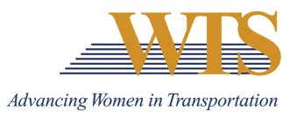

2023 WTS MINNESOTA AWARD NOMINATION
WOMAN TO WATCH
COVER SHEET

The Woman to Watch award recognizes women who are entry to mid-level in their transportation careers and have already made an impact on the transportation industry.

Awards are competitive and based on the nominee's specific goals and achievements. Please complete the contact information, summary response and supplemental responses. Nominations must be submitted as 1 PDF and are due via this google form by January 13 at 5 pm.
Questions? Contact Emily Jorgensen at emily.jorgensen@co.washington.mn.us

Nominee Information
Name:
Title:
Agency:
Email:
Phone:

Your Information
Name:
Title:
Agency:
Email:
Phone:

2023 WOMAN TO WATCH
Application

Please respond to each the following questions separately. Each response should be no more than 500 words. Specific examples are encouraged.

Question 1: The Woman to Watch award recognizes women who are entry to mid-level in their transportation careers and have already made an impact on the transportation industry. Describe why this nominee deserves to win. Max 500 words.

Question 2: Explain how this nominee is a woman who has…
- Made a positive impact as a young transportation professional
- Distinguished herself from other young professionals in the transportation industry
- Demonstrated leadership in the transportation industry
Max 500 words.

