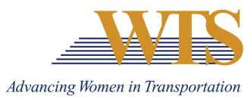

2023 WTS INTERNATIONAL AWARD NOMINATION
INNOVATIVE TRANSPORTATION SOLUTIONS
COVER SHEET

The Innovative Transportation Solutions award salutes an innovative transportation project led by a woman.
Awards are competitive and based on the nominee's specific goals and achievements. Please complete the contact information, summary response and supplemental responses. Nominations must be submitted as 1 PDF and are due via this google form by January 13 at 5 pm.
Questions? Contact Emily Jorgensen at emily.jorgensen@co.washington.mn.us

Nominee Information
Name:
Title:
Agency:
Email:
Phone:

Your Information
Name:
Title:
Agency:
Email:
Phone:

2023 INNOVATIVE TRANSPORTATION SOLUTIONS AWARD
Application

Please respond to each the following questions separately. Each response should be no more than 500 words. Specific examples are encouraged.

Question 1: The Innovative Transportation Solutions award salutes an innovative transportation project led by a woman. Describe why this nominee deserves to win. Max 500 words.

Question 2: Please describe the following about the project…
- The purpose of the transportation initiative, solution, project or policy and the number of women involved from initiation to completion.
- Identify the key elements of the project and how the female project manager successfully implemented those elements.
- Illustrate how the female project manager successfully met and overcame challenges.
- Explain how the project achieved its purpose.
Max 500 words.

