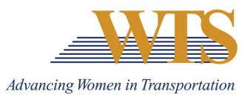

2023 WTS AWARD NOMINATION
WOMAN OF THE YEAR
COVER SHEET

The Woman of the Year Award is designed to reach out to honor a woman who is an outstanding role model in transportation.
Awards are competitive and based on the nominee's specific goals and achievements. Please complete the contact information, summary response and supplemental responses. Nominations must be submitted as 1 PDF and are due via this google form by January 13 at 5 pm.
Questions? Contact Emily Jorgensen at emily.jorgensen@co.washington.mn.us

Nominee Information
Name:
Title:
Agency:
Email:
Phone:

Your Information
Name:
Title:
Agency:
Email:
Phone:

2023 WOMAN OF THE YEAR
Application

Please respond to each the following questions separately. Each response should be no more than 500 words. Specific examples are encouraged.

Question 1: The Woman of the Year Award is designed to reach out to honor a woman who is an outstanding role model in transportation. Describe why this nominee deserves to win. Max 500 words.

Question 2: Describe how this nominee is…
- A woman who is a leader in transportation and has made an outstanding contribution to the transportation industry
- A woman who has directly contributed toward the advancement of women and minorities through programs or opportunities in the transportation field
- A woman who through her career advancements and support of women in the industry has advanced the reputation and credibility of women in transportation
Max 500 words.

