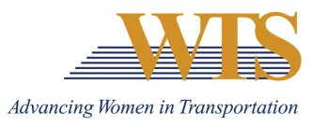

2023 WTS AWARD NOMINATION
MEMBER OF THE YEAR
COVER SHEET
The Member of the Year award acknowledges a WTS member who has made extraordinary contributions to the success of the organization.

Awards are competitive and based on the nominee's specific goals and achievements. Please complete the contact information, summary response and supplemental responses. Nominations must be submitted as 1 PDF and are due via this google form by January 13 at 5 pm.
Questions? Contact Emily Jorgensen at emily.jorgensen@co.washington.mn.us

Nominee Information
Name:
Title:
Agency:
Email:
Phone:

Your Information
Name:
Title:
Agency:
Email:
Phone:

2022 MEMBER OF THE YEAR
Application

Please respond to each the following questions separately. Each response should be no more than 500 words. Specific examples are encouraged.

Question 1: The Member of the Year award acknowledges a WTS member who has made extraordinary contributions to the success of the organization. Describe why this nominee deserves to win. Max 500 words.

Question 2: Describe how this member has….
- A member who has shown extraordinary commitment to the goals and growth of WTS
- A member who has promoted the reputation of WTS within the transportation industry
- A member who has worked effectively to strengthen communication between local and national levels or between chapters
- A member who has done an outstanding job of revitalizing or expanding a chapter or any of its functions
Max 500 words.

