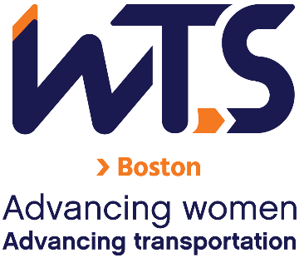
WTS-Boston Chapter Mentoring Program
Mentor Application

The WTS-Boston Mentoring Committee is seeking participants for the 2023 Mentoring Program. Please take a few minutes to review the program details below and consider becoming a mentor in the WTS-Boston Mentoring Program.
Mentors will be paired with mentees based on their career/employment background, leadership experience, and the mentee’s stated professional and mentoring program goals. Previous mentoring experience is not necessary, but is a plus.
Applications are due by November 4, 2022. Please email this application and other required documents to Sarah Davis and Estey Masten at wtsbostonmentoring@gmail.com.
Eligibility Criteria and Requirements
Eligibility:
- May or may not be a current member of WTS-Boston;
- Members who hold senior positions in transportation, public policy, or related fields and have the desire to assist others to grow personally and professionally; and/or
- Industry professionals with extensive experience in their chosen field with the ability to inspire their Mentees to learn and grow, seek new possibilities, take calculated risks and act as allies, catalysts and coaches;
- Ability to make a 6-month commitment from January-July 2023 encompassing 2-4 hours/month to the program.

Requirements:
- Complete this application.
- Submit a resume.
- Submit a 200-word bio describing your work history, leadership, and mentoring experience.

Application
Name
Employer and/or Organization
Position
Address
Email
Phone Number
- What are your expectations of the Mentoring Program? Why would you like to participate in the Program?

- Please note your preferred days/times to meet and preferred way to communicate with your mentee.

- Please mark your top three preferences for topics in the following table.
Topics | Mark a 1, 2, or 3 in this column next to your preferred professional development topics.
- Unconscious bias
- The business side of business
- Working from homeboundaries
- To family or not to family?
- Breaking the confidence code
- Virtual networking
- Working with different personalities
- Public speaking practice
- Keeping up with COVID productivity
- Other – Please indicate suggestions in the next column.

Applications are due November 4, 2022.

