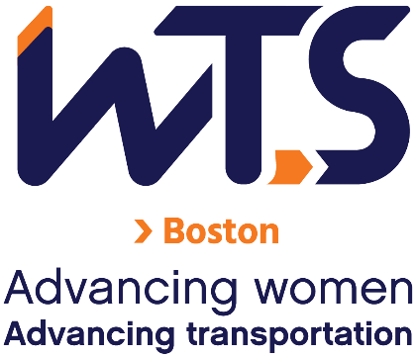

WTS-Boston Chapter Mentoring Program

Mentee Application

The WTS-Boston Mentoring Committee is seeking participants for the 2023 Mentoring Program. Participants will be selected based on the quality and thoroughness of their application. Please take a few minutes to review the program details below and consider becoming a participant in the WTS-Boston Mentoring Program.
Applications are due November 4, 2022. Please email this application and other required documents to Estey Masten and Sarah Davis at wtsbostonmentoring@gmail.com.

Eligibility Criteria and Requirements
Eligibility:
- Current Member of WTS-Boston. To join WTS, visit the following link: https://www.wtsinternational.org/about-wts/member-types/
- Ability to make a time commitment of 2-4 hours/month between January and July 2023.
Requirements:
- Complete this application.
- Submit a resume.
- Submit a 200-word bio describing your work history and experience.

Application
Name
Employer and/or Organization
Position
Email
Phone Number

- Briefly describe your professional goals:

- Describe what you are looking for in a mentor:

- Please note your preferred days/times to meet and preferred way to communicate with a mentor.

- Please mark your top three preferences for topics in the following table.
Topics | Mark a 1, 2, or 3 in this column next to your preferred professional development topics.
- Unconscious bias
- The business side of business
- Working from home boundaries
- To family or not to family?
- Breaking the confidence code
- Virtual networking
- Working with different personalities
- Public speaking practice
- Keeping up with COVID productivity
- Other – Please indicate suggestions in the next column.

Applications are due November 4, 2022.

