WTS International Annual Conference Scholarship Application
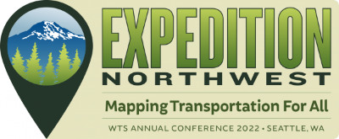
The WTS Houston Board of Directors will be awarding four scholarships to cover the cost of registration for the 2022 WTSI Annual Conference on May 18 -20, 2022 in Seattle, Washington. Criteria for selection will be based on the applicant’s contributions to the chapter and the potential benefits of conference attendance to the applicant and the chapter.
Please complete the form below and email it with your statement of interest to Stephanie.Guillot@aecom.com. In your email, type “2022 WTSI Annual Conference Scholarship” as the subject line. All applications must be received by FRIDAY, March 11, 2022.
For more information about the 2022 WTSI Annual Conference, visit: https://www.wtsinternational.org/2022-annual-conference

Section I: Applicant Information

Full Name:

Email:

Current Employer:

Current Position:

WTS Member Since:

Phone Number:

Have you ever attended a WTS Annual Conference? Yes ___ No ___

DOES YOUR EMPLOYER SUPPORT WTS hOUSTON AND APPROVE YOUR ATTENDANCE? Yes ___ No ___

Section II: Statement of Interest
In support of your application to attend the 2022 WTSI Annual Conference, please provide an up to one page statement of interest that addresses the following:
- Describe your interest in attending the conference. How will attending this conference support your career goals? How will your attendance at the conference benefit the Houston Chapter of WTS?
- Describe your past and present involvement in the WTS Houston chapter and in particular, any specific contributions you have made in furthering our mission of advancing women in transportation.

