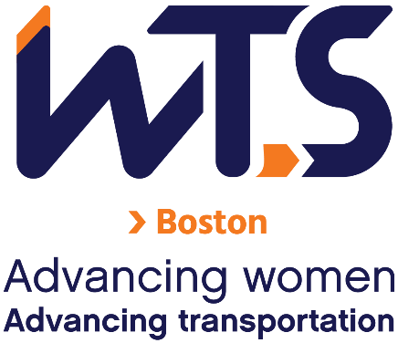

2022 Program for Emerging Professional Women

WTS-Boston recognizes the importance of supporting emerging professionals as a means of sustaining the long-term viability of our Chapter. As one of several efforts to ensure the future success of our Chapter, the Program for Emerging Professional Women will assist in the development of future leaders by providing annual awards to the WTS-Boston community.

Eligible applicants must work in a transportation-related career and not be eligible to receive reimbursement from their employer for WTS membership expenses. Applicants should have no more than 5 years of full-time post-graduate professional experience in the transportation field.

Selected participants of the Program for Emerging Professional Women will receive the following:
- Paid membership dues from January through December 2022.
- Opportunity to attend virtual events and paid attendance at in-person events in 2022.
- Advisor commitment from a senior WTS-Boston board member or industry leader through December 2022.

Through the course of their term, selected participants must agree to Chapter involvement and professional development by meeting the following requirements:
- Attend at least two Board meetings (one of which shall be in January or February; the other shall be in the Fall)
- Assume an active, responsible committee role or other position of responsibility in the Chapter
- Write a minimum of one (1) short essay or reflection (for possible Fall 2022 eblast publication) on their experiences with the program.
- Provide monthly updates to the Mentoring Committee to show progress about program requirements.
- Attend monthly check-ins with EP liaisons and the EP cohort.
- Meet with their WTS advisor a minimum of three (3) times during the course of the year; and
- Demonstrate their support/networking with other emerging professionals in the transportation field.

With the assistance of their WTS-Boston advisor, each selected participant must establish a set of goals for success in the Program and meet these goals over the course of their term. These goals should be identified in January and should include: active participation in WTS-Boston, support of the WTS-Boston Chapter goals, support and development of women in the transportation industry, and advancement of their own professional development goals.

A Selection Committee will review applications and make recommendations to the Board of Directors who will vote on the selected participants. The process is competitive and based on the applicant’s specific goals for serving in the Chapter and description of how these goals will benefit their career as well as the WTS-Boston Chapter.

Applications must be submitted as a compiled PDF via email to wtsbostonmentoring@gmail.com
no later than 5:00 pm on Thursday, November 4, 2021.

WTS – Boston Chapter
______________________________________________

2022 Program for Emerging Professionals Application
______________________________________________

Personal Information

Last First Middle

Current Address

Street City State Zip Code Telephone

Email Address

Current Employment

Current Employer/Company

Employer Address

Street City State Zip Code Telephone

Job Title

Date of Hire

Total Years Professional Experience in Transportation

Resume (Educational & Employment History)
Please include a summary of your educational background and a brief employment history. (Attach additional sheets if necessary.)

Educational background information should include the following information:
- Colleges/universities attended, dates, and degree(s) earned.
- Leadership activities (clubs, internships, committees, volunteer activities, etc.).

Employment history should include the following information:
- Job title, start/end dates, employer, and brief job description for each position held.
- Professional leadership activities (professional committees, organizations, volunteer activities, etc.).
- Briefly describe the duties and responsibilities of your current job position and how your job relates to the transportation field.

- Personal Statement: Describe in 500 words or less why you feel you are a good candidate for the program. Address your goals for success in the Program by: (1) identifying a role you might like to serve in the Chapter, (2) describing how your career could benefit from performing such a role, and (3) describing how WTS-Boston could benefit from your commitment.

- Eligibility verification: Provide verification from your employer that you meet the eligibility criteria with respect to non-reimbursement. (A letter from your supervisor confirming you meet the criteria is sufficient.)

- Recommendation: Letter of recommendation by a job supervisor or other person familiar with your work abilities, interests, and dedication must accompany your application.

If selected for the Program for Emerging Professional Women, I agree to meet all requirements established for Chapter involvement and personal professional growth.

Signature Date

