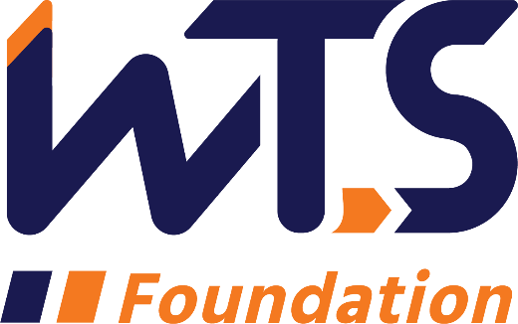

WTS Central PA Chapter - Colleen Brown High School Scholarship
WTS works to make a difference in the lives of young women and girls by offering opportunities and activities that will spark their interest in all modes of transportation and encourage them to take courses in science, technology, engineering and math (STEM) which are the stepping stones to exciting careers that can change the face of the transportation industry. The WTS Central PA Chapter – Colleen Brown High School Scholarship is available to high school senior girls pursuing studies in STEM and considering a transportation-related career.
Colleen grew up in the City of Lancaster and decided early on that she wanted to be an engineer. She graduated magna cum laude from University of Pittsburgh at Johnstown with a Bachelor of Science degree in civil engineering. In 1984, not long after graduation, she started working for the Pennsylvania Department of Transportation (PennDOT) in the Civil Engineer Training Program and in 1997, Colleen advanced to a Project Development Engineer. Colleen was a highly-respected engineer and was well-liked by all who worked with her. She had a twinkle in her eye, an energetic “get it done” attitude, and a quick sense of humor. In September 2010, Colleen passed away at age 49 after a courageous battle with pancreatic cancer. She had worked as an engineer for PennDOT for 26 years.

The minimum criteria for selection are:

a. Applicant must be a high school senior.
b. GPA of 3.0 or higher. A multi-year high school report card or transcript is required.
c. Currently studying math, science, and/or technology.
d. Considering a college degree in a STEM-related, transportation field.
e. Applicant must reside in Pennsylvania or attend school in Pennsylvania.

Applications must be submitted through the WTS Central PA Chapter as a typed Word document or PDF document. File names should include the scholarship name and last name of applicant (ex. Colleen Brown_Smith.pdf). Preferred submission is one, compiled PDF with all attachments included. Scholarships are competitive and based on the applicant's specific STEM-related career goals, academic record, and STEM-related activities or job skills. Please review our WTS Central PA chapter scholarship "Tips" document and scholarship announcement letter. Contact information to submit application is located on the last page of this application.

One applicant may be recommended by the Central PA Chapter for the national WTS Foundation Transportation YOU scholarship competition. National awards will be presented during the WTS Annual Conference in spring 2021. Conference registration for scholarship winners is complimentary.

WTS Central PA Chapter - Colleen Brown High School Scholarship

I. Personal Information

Name________________________________________________________________
Last First Middle

E-mail address_________________________________________________________
Primary Phone (___)_____________________________________________________
Current Address (Street, City, State, Zip): _____________________________________________________________________
_____________________________________________________________________
_____________________________________________________________________
Permanent Address (Street, City, State, Zip): _____________________________________________________________________
_____________________________________________________________________
_____________________________________________________________________

Educational Background

Current High School _______________________ City, State_____________
Expected Date of Graduation___________
Area of Concentration____________________________________________________
Grade Point Average____________
(Minimum GPA of 3.0 required. Attach copy of multi-year report card or transcript to application.)

Professional or School Affiliations (List any school, professional or community activities you have participated in. Include offices held and awards received. Attach additional sheets, if necessary, as typed word documents.)

__________________________________________________________________
_____________________________________________________________________
_____________________________________________________________________
_____________________________________________________________________
_____________________________________________________________________
_____________________________________________________________________
_____________________________________________________________________
_____________________________________________________________________
_____________________________________________________________________
______________________________________________________________________
____________________________________________________________________

III. Recommendation: Letter of recommendation by a teacher, counselor, or principal must accompany your application.

IV. Personal Statement: A statement about your goals to pursue studies in STEM (science, technology, engineering, or math) while in college to prepare for a transportation-related career and why you think that you should receive the scholarship award. Statement should not exceed 500 words. Please attach as a word document to application form.

Signature_____________________________________Date___________________

Parent/Guardian Signature_____________________________________Date___________________

Please send application and attachments to:

CentralPA@wtsinternational.org (preferred)

OR

Hannah Landvater, WTS Central PA Scholarship Chair
c/o RK&K
651 East Park Drive, Suite 105
Harrisburg, PA 17111

