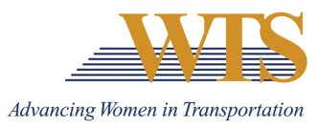

2021 WTS MINNESOTA AWARD NOMINATION

WOMAN TO WATCH

COVER SHEET

Chapter Information
Chapter: Minnesota
Contact: Emily Jorgensen
Chapter Title: Scholarships & Recognitions Director
Email of Contact: emily.jorgensen@co.washington.mn.us
Phone of Contact: 651-430-4338

Nominee Information
Nominee:

Contact (if nominee is a company):

Email:

Phone:

Your (Nomination Author) Information
Name:

Email:

Phone:

Title:

Company:

2021 WTS MINNESOTA AWARD NOMINATION

Describe why this nominee deserves to win.

2021 WOMAN TO WATCH

SUPPLEMENTAL INFORMATION
Please answer the following questions.
Nominee:

- Explain how this nominee is a woman who has made a positive impact as a young transportation professional

- Explain how this nominee is a woman who has distinguished herself from other young professionals in the transportation industry

- Explain how this nominee is a woman has demonstrated leadership in the transportation industry

