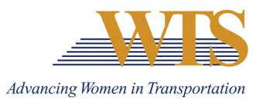

2021 WTS INTERNATIONAL AWARD NOMINATION
WOMAN OF THE YEAR
COVER SHEET

Chapter Information
Chapter: Minnesota
Contact: Emily Jorgensen
Chapter Title: Scholarships & Recognitions Director
Email of Contact: emily.jorgensen@co.washington.mn.us
Phone of Contact: 651-430-4338

Nominee Information
Nominee:

Contact (if nominee is a company):

Email:

Phone:

Your (Nomination Author) Information
Name:

Email:

Phone:

Title:

Company:

2021 WOMAN OF THE YEAR
SUMMARY FORM

Describe why this nominee deserves to win.
2021 WOMAN OF THE YEAR
SUPPLEMENTAL INFORMATION
Please describe how your nomination embodies the following descriptions.
Nominee:

- A woman who is a leader in transportation and has made an outstanding contribution to the transportation industry

- A woman who has directly contributed toward the advancement of women and minorities through programs or opportunities in the transportation field

- A woman who through her career advancements and support of women in the industry has advanced the reputation and credibility of women in transportation

