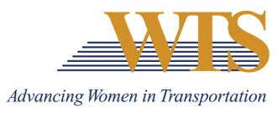
2021 WTS INTERNATIONAL AWARD NOMINATION
ROSA PARKS DIVERSITY LEADERSHIP
COVER SHEET

Chapter Information
Chapter: Minnesota
Contact: Emily Jorgensen
Chapter Title: Scholarships & Recognitions Director
Email of Contact: emily.jorgensen@co.washington.mn.us
Phone of Contact: 651-430-4338

Nominee Information
Nominee:

Contact (if nominee is a company):

Email:

Phone:

Your (Nomination Author) Information
Name:

Email:

Phone:

Title:

Company:

2021 ROSA PARKS DIVERSITY LEADERSHIP AWARD
SUMMARY FORM

Describe why this nominee deserves to win.

2021 ROSA PARKS DIVERSITY LEADERSHIP AWARD
SUPPLEMENTAL INFORMATION

Nominee:

Exhibiting extraordinary efforts or initiatives in facilitating professional opportunities for women and minorities.

Contributing significantly to promoting diversity, inclusion and multi-cultural awareness within their organization, the transportation industry, or in a project or activity that supports the goals and mission of WTS.

