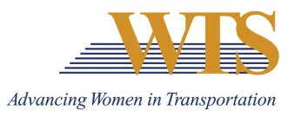

2021 WTS INTERNATIONAL AWARD NOMINATION
MEMBER OF THE YEAR
COVER SHEET

Chapter Information
Chapter: Minnesota
Contact: Emily Jorgensen
Chapter Title: Scholarships & Recognitions Director
Email of Contact: emily.jorgensen@co.washington.mn.us
Phone of Contact: 651-430-4338

Nominee Information
Nominee:

Contact (if nominee is a company):

Email:

Phone:

Your (Nomination Author) Information
Name:

Email:

Phone:

Title:

Company:

2021 MEMBER OF THE YEAR
SUMMARY FORM

Describe why this nominee deserves to win.

2021 MEMBER OF THE YEAR
SUPPLEMENTAL INFORMATION

Please describe how your nomination embodies the following descriptions.
Nominee:

- A member who has shown extraordinary commitment to the goals and growth of WTS

- A member who has promoted the reputation of WTS within the transportation industry

- A member who has worked effectively to strengthen communication between local and national levels or between chapters

- A member who has done an outstanding job of revitalizing or expanding a chapter or any of its functions

