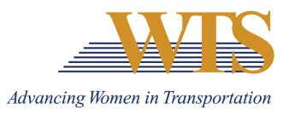

2021 WTS INTERNATIONAL AWARD NOMINATION
INNOVATIVE TRANSPORTATION SOLUTIONS
COVER SHEET

Chapter Information
Chapter: Minnesota
Contact: Emily Jorgensen
Chapter Title: Scholarships & Recognitions Director
Email of Contact: emily.jorgensen@co.washington.mn.us
Phone of Contact: 651-430-4338

Nominee Information
Nominee:

Contact (if nominee is a company):

Email:

Phone:

Your (Nomination Author) Information
Name:

Email:

Phone:

Title:

Company:

2021 INNOVATIVE TRANSPORTATION SOLUTIONS AWARD

SUMMARY FORM

Describe why this nominee deserves to win.

2021 INNOVATIVE TRANSPORTATION SOLUTIONS AWARD

SUPPLEMENTAL INFORMATION
Please answer the following prompts.

Nominee:

- Describe the purpose of the transportation initiative, solution, project or policy and the number of women involved from initiation to completion.

- Identify the key elements of the project and how the female project manager successfully implemented those elements.

- Illustrate how the female project manager successfully met and overcame challenges.

- Explain how the project achieved its purpose.

