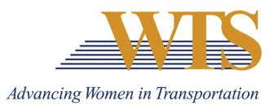

2021 WTS INTERNATIONAL AWARD NOMINATION
HONORABLE RAY LAHOOD AWARD
COVER SHEET

Chapter Information
Chapter: Minnesota
Contact: Emily Jorgensen
Chapter Title: Scholarships & Recognitions Director
Email of Contact: emily.jorgensen@co.washington.mn.us
Phone of Contact: 651-430-4338

Nominee Information
Nominee:

Contact (if nominee is a company):

Email:

Phone:

Your (Nomination Author) Information
Name:

Email:

Phone:

Title:

Company:

2021 HONOROBALE RAY LAHOOD AWARD

SUMMARY FORM

Describe why this nominee deserves to win.

2021 HONORABLE RAY LAHOOD AWARD

SUPPLEMENTAL INFORMATION

Please describe how your nomination embodies the descriptions below.

Nominee:

- A man who is a leader in transportation and has made an outstanding contribution to the transportation industry

- A man who has directly contributed toward the advancement of women and minorities through programs or opportunities in the transportation field

- A man who has led by example, seeking out opportunities to advance and advocate for women in his own organization, and who has actively ensured that women are able to compete for key positions of authority within that organization

- A man who through his career advancements and support of women in the industry has advanced the reputation and credibility of women in transportation

