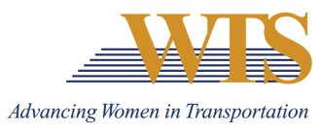

2021 WTS INTERNATIONAL AWARD NOMINATION
EMPLOYER OF THE YEAR
COVER SHEET

Chapter Information
Chapter: Minnesota
Contact: Emily Jorgensen
Chapter Title: Scholarships & Recognitions Director
Email of Contact: emily.jorgensen@co.washington.mn.us
Phone of Contact: 651-430-4338

Nominee Information
Nominee:

Contact (if nominee is a company):

Email:

Phone:

Your (Nomination Author) Information
Name:

Email:

Phone:

Title:

Company:

2021 EMPLOYER OF THE YEAR
SUMMARY FORM

Describe why this nominee deserves to win.

2021 EMPLOYER OF THE YEAR
SUPPLEMENTAL INFORMATION

Please answer the following questions.
- Describe the organization’s structure, including the number of women in executive and senior positions and those leading major initiatives.

- Describe the career development plans and succession programs in place for women to advance within the organization.

- Describe and provide example(s) of how the organization provides continuing education of its female employees through:

• Professional education
• Professional organizations
• Professional development opportunities

- Describe and provide example(s) of how the organization encourages women students to enter the transportation field by providing internship opportunities.

- Describe and provide example(s) of how the organization supports WTS through memberships, sponsorships, and employee involvement at the local and international levels.

